FACULTY OF CIVIL AND ENVIRONMENTAL ENGINEERING
Chair of …
Prof. Dr. …

Master thesis
Title of the thesis in one
or two lines

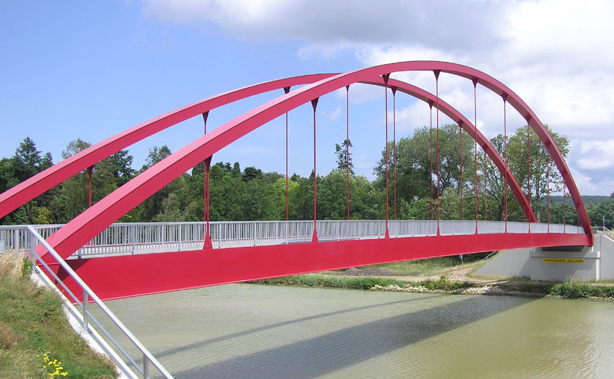

Student: | First and last name
Matriculation number: | 108 ...

Date | 02. May 2017

Copy of the output sheet of the Master thesis

Table of contents
1 Template for documents 2
1.1 Text - FORMATS 2
1.2 List formats 2
2 Structure of the template 2
2.1 Formulas 2
2.1.1 How to insert a formula? 2
2.2 M_Formate for figures and co. 2
2.2.1 Tables 2
2.2.2 Images 2
2.2.2.1 Heading 4 2
3 Include literature 2
4 Statement of independent work 2

List of figures
Fig. 2.1 Text format M_Bildunterschrift, font size 9, line height 14.5 2

Template for documents
This is a template for writing theses at the Chair of Steel, Lightweight and Composite Structures at RUB.
Please use this template with the formatting options presented here. For this purpose, the format templates labeled A_Beispiel are intended for whole paragraphs. The formats Z_Beispiel are to be used for single words. A maximum of 4 headings are to be used (Überschrift 1 to 4). Furthermore, there is M_Beispiel for inserting pictures, formulas and tables and Liste_Beispiel for enumerations and lists.

A_Text is the default text. Font Arial.
Start with page 1
Header with chapter number, chapter text and page number
(1.1)

Text - FORMATS
A_Text Normal text
A_Formate for the whole paragraph, Z_Formate only for single words. M_Formate for captions and co.
A_Text_Tabelle Text in tables smaller for tables
A_LeerzeichenNachTabelle for a space under tables

A_Überschrift 1 ohne Nummerierung and without page break for content listing and appendix
Note For Notes During Editing
M_Bilder line spacing variable
Z_Symbol A_
Z_Durchgestrichen / Hoch / capital / subscript
Z_Durchgestrichen / superscript / capital / subscript
Z_Durchgestrichen / superscript / capital / subscript
Z_Durchgestrichen / superscript / capital / subscript
Z_Durchgestrichen / superscript / capital / subscript / bold

List formats
- Liste_a
- Liste_a

- Liste_A
- 4225
- Liste_Bu
- Liste_Bu

- Liste_Num
- Liste_Num
- asdfasdf
Format text after enumeration again with A_Text. For a new enumeration:
- Liste_a (right click: start numbering again)
- Liste_a
- a

Structure of the template
Heading 1 (Überschrift 1) always starts on the new page.

Formulas

How to insert a formula?
Copy another table, then only exchange formula.
Get current numbering via "Update fields”
Insert cross-reference for formula under the label "(".
Formula; font size 11, Arial in Mathtype
(2.1)
With CTRL+A and then F9 all fields can be updated!
M_Gleichung for equations, so that a variable line spacing is available.
M_Formelnummerierung for numbering, so that it is right-justified.

M_Formate for figures and co.
Normal Text.

Tables
For tables, figure etc. the labels must be defined first (on each PC). To do this, mark the corresponding object - right click - insert label. If the desired label is not available: new - select "Tab." as name, check the box for include chapter number (with dot or hyphen, as desired), above or below the object, as desired. Only then can a reference be created with "Insert cross-reference". In doing so, the name of the table must be designated as it is to appear later in the text. "see Tab. 2.1" requires the name "Tab.". After inserting the name, define it in the format M_Bildunterschrift.

If desired, insert a blank line below the table with A_Leerzeichen_nach_Tabelle corresponding to ½ line height. After inserting the name, define the table heading with the format M_Tabelle. Table heading is not separated from table at page change
Table 2.1
Table in font size 9. Line spacing left at 14.5 | Table text in A_Text_Tabelle
Insert caption
Blank line after table
If desired, insert a blank line below the table with A_Leerzeichen_nach_Tabelle equaling ½ line height.
Table designation above the table in M_Tabelle

M_Bilder: centered, variable line spacing for images
M_Bildunterschrift caption for images
M_Gleichung for formulas with Mathtype, variable line height
M_Formelnummerierung formula numbering
M_Tabelle caption for tables

Images
Insert images as references
Use format "M_Bilder", because other formats have a fixed line height. Image and caption below are NOT separated on two pages.
Caption with: "Insert caption", format: M_Bildunterschrift. After inserting the caption still define the caption with the format M_Bildunterschrift.
Fig. 2.1 Text format M_Bildunterschrift, font size 9, line height 14.5
Normal text: member buckling failure stability theory of straight members that have at least one line of symmetry in the cross-section, are loaded in their cross-sectional plane, and also fail in this plane due to member buckling.
In Fig. 2.1, three penguins can be seen Insert - cross-reference

Heading 4
No other headings are expected.

Include literature
Insert references e.g. using Citavi...
Alphabetical and chronological order
Meier shows in [1, 2] …
[3] shows….
Please leave section breaks before the list of references!

List of references
[1] DIN EN 1993-1-9:12/2010. Eurocode 3: Bemessung und Konstruktion von Stahlbauten – Teil 1-9: Ermüdung.
[2] Haibach, E. 2006. Betriebsfestigkeit. Verfahren und Daten zur Bauteilberechnung. VDI-Buch. Springer. Berlin
[2] Kindmann, R. 2008. Stahlbau. Teil 2: Stabilität und Theorie II Ordnung. Bauingenieur-Praxis, Bd. 2. Ernst und Sohn. Berlin.
[3] Kragerup, J. 1984. Buckling of rectangular, unstiffened steel plates in compression. Dissertation, Technical University of Denmark Lyngby. Denmark.
[5] Pedersen, M. M.; Andersen, J. G.; Olafsson, O. M. 2012. Investigation of the thickness effect for butt welded joints. IIW WG1-154-12.
[4] Rauch, M.; Knobloch, M. Challenges for tower structures of multi-megawatt class wind turbines. In: Zingoni, A. (Hrsg.): Insights and Innovations in Structural Engineering, Mechanics and Computation. Proceedings of the Sixth International Conference on Structural Engineering, Mechanics and Computation, Cape Town, South Africa, 5-7 September 2016. Boca Raton: CRC Press 2016, S. 335–336 (full paper on CD-ROM)

Statement of independent work
I hereby declare that the work in this Master thesis represents a result of my own independent work, carried out in accordance with the requirements of the University’s Regulations and Code of Practice for Research Programmes, without the use of any sources beyond those cited in the references. This includes possible figures or tables. Furthermore, I ensure that: no other persons were involved in the preparation of the present work or have received any monetary benefit from me for the work presented, unless indicated as such; the thesis has not been submitted to any other examination authorities or for any academic awards in the same or a similar form either in Germany or abroad; the submitted report represents the research work with independent views, opinions, results and conclusions conducted under the guidance of my supervisor.
I am aware that a noncompliance with this declaration may result in a grading of my work as “failed”. I also know that a copyright violation as well as an attempted fraud may be prosecuted and a deliberate infringement on any laws concerning cheating constitutes an administrative offence, for which may result in serious consequences. In case of repeated or particularly severe attempts of deception a forced exmatriculation might ensue.

__________________________ __________________________
(First and last name) (Date)

